Machine Learning Final Project

Topic: Employee Attrition Prediction

Group 6

Members:
Ke Ping Lo
Jorge Emmanuel Efrain Carrasco Fredes
Obinna Ekere
Rilwan Ayoola
Emmanuella Adwubi Appiah

Introduction
Employee turnover is a big headache for companies. When people leave, the company must spend money to find new people, train them, and wait for them to learn the job. It also hurts team morale when a good coworker leaves.

In this project, we used a dataset from an organization that has information about 1,470 employees. It tells us things like their age, how much money they make, if they work overtime, how happy they are at work, and most importantly, whether they left the company or stayed.

Our job was to see if we can build a machine learning model that can look at this information and predict which employees are likely to quit. Think of it like a warning
system for HR.

Motivation
So why should anyone care about this?

Simple. If a company knows ahead of time that an employee might leave, they can do something about it. Maybe give them a raise. Maybe improve their work-life balance. Maybe offer them a promotion. Whatever it is, they can try to keep them.
Right now, most companies only find out someone is unhappy when they hand in their resignation letter. That's too late. By then, they've already made up their mind and probably have another job lined up.

We want to change that. We want to show that machine learning can help HR be smarter. Instead of just reacting to problems, they can see problems coming before they happen. That saves money, saves time, and keeps good people around.

Methodology Flowchart
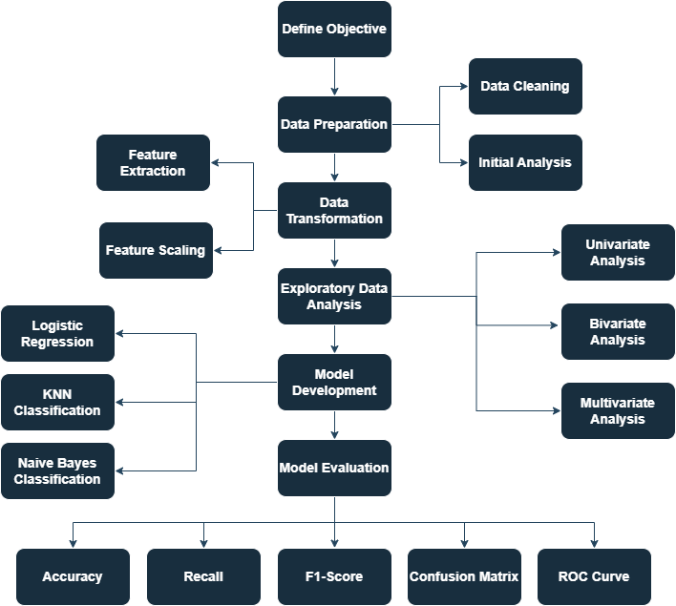

The methodology flowchart provides a visual overview of the end-to-end process followed in this project, outlining how the analysis progressed from problem understanding to model evaluation. It visually summarizes each major stage, beginning with defining objective, followed by data preparation and transformation, exploratory data analysis, model building and evaluation. Overall, it serves as a roadmap that shows the sequence of tasks we followed for this project.

Data Preparation
Data Cleaning
The attrition dataset contained 31 variables and 1,470 records describing employee demographics, job characteristics, compensation, and satisfaction levels. The dataset was examined to ensure consistency and reliability before analysis to ensure data quality. We also removed features not relevant to our model that may otherwise introduce noise in the model.
Duplicate records were identified and removed to prevent bias. A check for missing values showed that the dataset contained no missing data, allowing the analysis to proceed without the need for imputation.
Irrelevant columns that did not contribute to the analysis and model development were dropped. The variables that have no unique values indicates that they have only one constant values, therefore, we exclude them to reduce dimension and potentially reduce noise. The 4 variables that we removed includes:
- EmployeeNumber: This variable is a unique identifier that has no predictive value; therefore, we removed this variable to reduce dimension of the dataset.
- EmployeeCount: The count of each record is 1, which is obvious and has no significance.
- Over18: All the records are above the age of 18.
- StandardHours: All the employees worked for 80 hours.
Initial Analysis
Initial visualizations were conducted to understand the dataset before performing any analysis. This part of Data Preparation focuses on examining the overall structure, distribution, and variability of numerical variables.
Exploring the variable ‘Attrition’
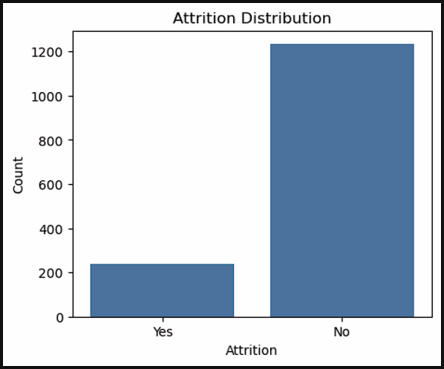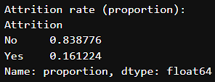
The bar chart shows a clear class imbalance, with a significantly larger number of employees staying compared to those who left. This imbalance is common in HR datasets and is important to recognize early, as it affects how model performance should be interpreted. The attrition rate observed is 16.12% while non-attrition is 83.88%.
Assessing Outliers and distribution of the variables
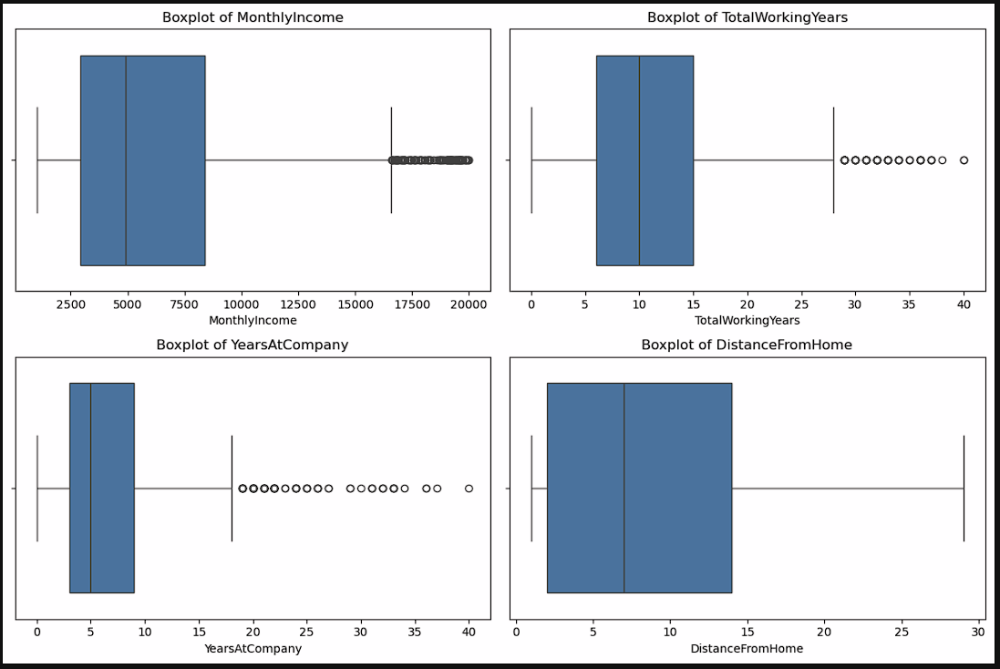
The purpose of creating these boxplots is to highlight the presence of outliers, differences in spread, and potential irregularities in the data.
MonthlyIncome- The boxplot for Monthly Income highlights the spread of salaries and identifies several high-income outliers. The wide range indicates variation in pay across job roles and levels. This visualization helps confirm that income is a variable with meaningful variability, making it relevant for deeper attrition analysis.
TotalWorkingYears- The boxplot shows a broad distribution, with employees ranging from early-career to highly experienced. A few outliers represent individuals who have worked in the company for long.
YearsAtCompany- The boxplot shows that most employees have relatively short tenure, with a few long-tenured outliers. This is in contrast with the histogram of YearsAtCompany and confirms that tenure varies widely, making it a potentially important factor in attrition.
DistanceFromHome- The boxplot shows that most employees live relatively close to the workplace. The long tail represents employees who have to commute much farther. This variation suggests that commute distance may influence employee satisfaction and is worth examining in relation to attrition.
Distribution Analysis
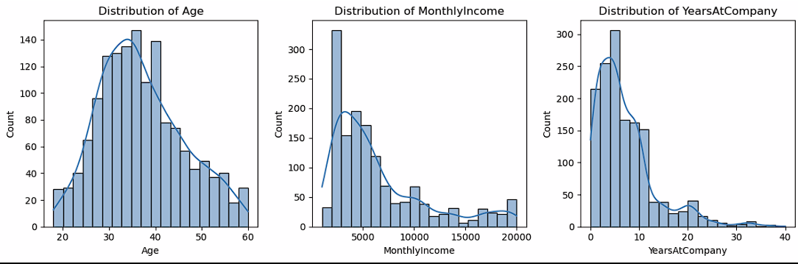
The focus of this analysis is to observe central tendencies, skewness, and the general shape of the data. These plots helped identify whether the workforce was young or older, whether income was evenly distributed or skewed, and whether most employees had short or long tenure.
Age Distribution- The distribution is slightly right-skewed, with most employees falling between their late 20s and early 40s. Very young and very old employees make up a smaller portion of the workforce. This tells us the general age structure of the company and confirms that the dataset contains a mature employee population.
MonthlyIncome Distribution- The distribution is heavily right-skewed, pointing out that most employees earn on the lower end of the salary range, and only a small number earn very high incomes. This skewness is typical in corporate salary structures and indicates that income is not evenly distributed.
YearsAtCompany Distribution- The histogram shows a large proportion of employees having relatively short tenure, with the distribution decreasing as years increase. This suggests that the workforce contains many newer employees and fewer long-tenured staff.

Data Transformation/ Preprocessing Parameters
Data transformations were applied to prepare the dataset for machine learning.
Feature Extraction
Binary Encoding: The dataset was transformed to make it suitable for machine learning models. The target variable, attrition, was converted from categorical values (“Yes” and “No”) into binary form (1 and 0).
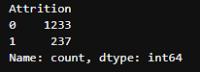
One-hot Encoding: Categorical variables were converted into numerical format using one-hot encoding. This allowed the models to process categorical data effectively.
Feature scaling
We normalized the data using a standard scaler where all numerical variables used were scaled to mean=0 and standard deviation=1. This ensures that all variables are on a similar scale, which is especially important for distance-based algorithms such as K-Nearest Neighbors (KNN).
Train-Test Split Validation
The dataset was split into 70% training data and 30% test data to evaluate model performance on unseen data. This approach ensured that the models were tested on their ability to generalize.

Exploratory Data Analysis (EDA)
Exploratory Data Analysis was conducted to identify patterns related to employee attrition. The analysis began with univariate exploration, where individual variables were examined using histograms to understand their distributions, central tendencies, and skewness. This was followed by bivariate analysis, using boxplots and comparisons across Attrition groups to reveal how continuous variables differ between employees who stayed and those who left. Finally, multivariate analysis was performed through a single-target correlation heatmap, allowing us to assess the relationships between multiple features and the Attrition variable simultaneously.
Univariate Analysis
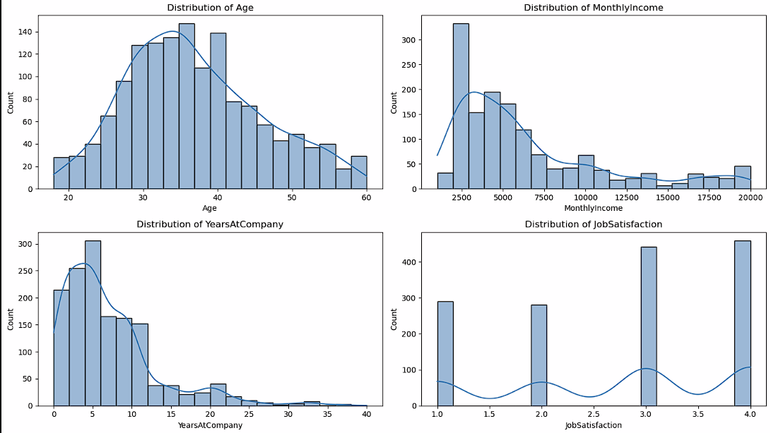
These distribution gives us an idea of what might drive attrition.
- Age: The age distribution of the workforce is clustered between the range of 30-40 years. The middle-aged employees usually have lower intention to leave the company due to personal responsibilities which is why they would prefer job security. Younger employees on the other hand might have a higher change of attrition. They have higher risk appetite and longer time horizon before them which is why they would want to explore other opportunities and seek faster career growth.
- MonthlyIncome: This distribution is right-skewed, with many employees earning on the lower end. Low-income employees have a higher chance of attrition while the high-income earners tend to stay in the company.
- YearsAtCompany: The distribution is also right-skewed, indicating that majority of the employees have low tenure between 0-5 years. Employees with short tenure are generally more likely to leave the company.
- JobSatisfaction: From the distribution, most of the employees are satisfied with their job while less than half are not. The employees with low job satisfaction shows higher attrition rate and should be paid more attention to retain talent.
Across all four variables, a consistent pattern emerges where younger and Lower-income employees with Short-tenured, and Employees with low job satisfaction are more likely to leave.
Bivariate Analysis
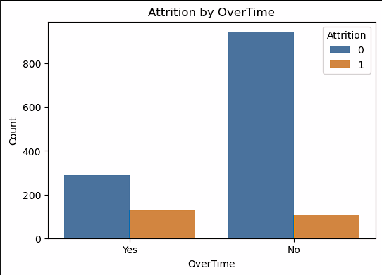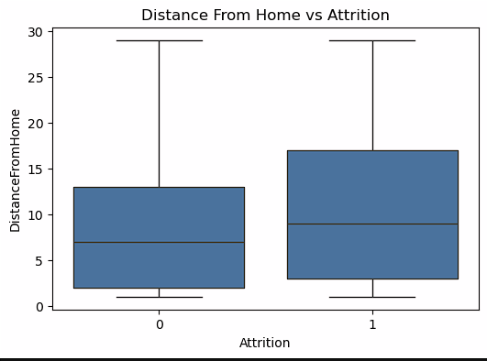
Attrition by Overtime
The bar chart shows that employees who do not work overtime relatively have a higher count of non-attrition, indicating that the majority of them remain with the company. In contrast, employees who do work overtime show a noticeable proportion of attrition relative to their group size. Although the number of attrition cases is smaller overall, the difference in proportions is clear: employees who work overtime are more likely to leave the organization.
DistanceFromHome v/s Attrition
The boxplot reveals a similar pattern yet subtle. Employees who left the company tend to live slightly farther from the workplace than those who stayed. The median distance for the attrition group is higher, and the interquartile range is wider, indicating greater variability in commute length among employees who left. Although both groups share similar minimum and maximum values, the upward shift in the central tendency suggests that longer commute distances may contribute to dissatisfaction or reduced work–life balance.
Bar-chart with Error bars
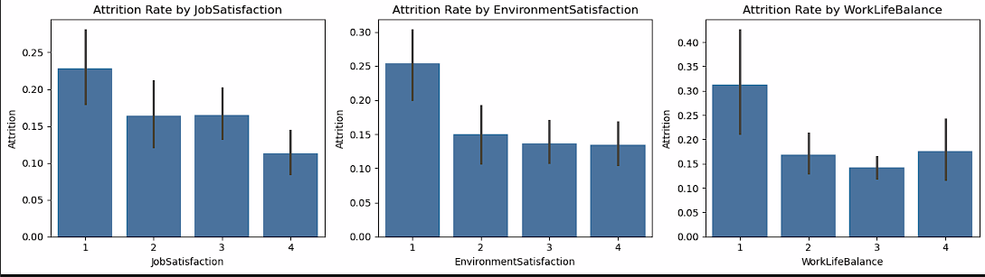
- Attrition by JobSatisfaction: Employees with the lowest satisfaction level have the highest attrition rate, while those with the highest satisfaction have the lowest turnover. The decline in attrition as satisfaction increases suggests that employees who feels valued and engaged in their roles are significantly less likely to leave.
- Attrition by EnvironmentSatisfaction: Employees who rate their work environment poorly have the highest attrition rate. As satisfaction improves from levels 2 to 4, attrition decreases noticeably. This indicates that the physical and psychological work environment such as workplace culture, safety, and support plays an important role in employee retention. Employees who perceive their environment as unsupportive or stressful are more likely to seek opportunities elsewhere.
- Attrition by WorkLifeBalance: Employees with the lowest work-life balance rating have the highest attrition rate, exceeding 0.3 or 30%. Attrition drops sharply for employees with moderate to high work-life balance ratings, with the lowest observed at level 3. This suggests that employees who struggle to balance personal and professional life are at higher risk of leaving. Poor work-life balance often results from excessive workload, long hours, or unpredictable schedules, resulting in employee’s burnout from work.
Grouped Bar Charts
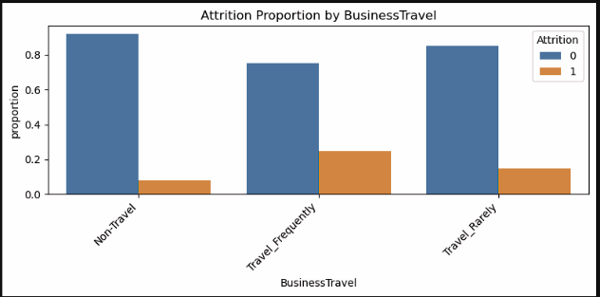
Attrition by BusinessTravel
The bar chart clearly shows employees who do not travel have the lowest attrition proportion, suggesting that a stable, predictable work routine supports retention. Attrition increases among those who travel rarely and is highest among employees who travel frequently. Frequent travel can contribute to fatigue, work–life imbalance, and stress, which may explain the higher turnover.
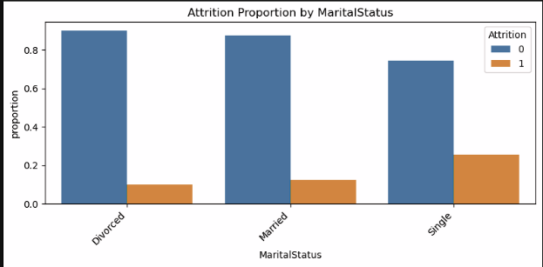
Attrition by MaritalStatus
The chart reveals that single employees have a significantly higher proportion of attrition compared to married or divorced employees. Married and divorced individuals show much higher proportions of non-attrition, indicating greater stability. This pattern may reflect lifestyle differences—single employees may have fewer family-based commitments, greater mobility, or a higher likelihood of pursuing new opportunities.

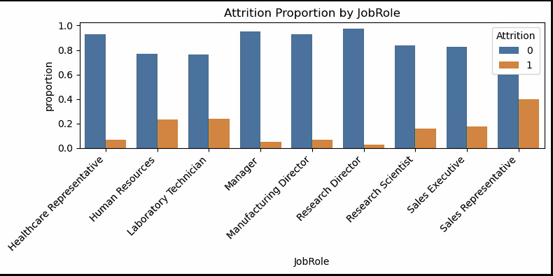
Attrition by JobRole
The chart shows that most roles have low attrition rate however, Sales Representatives, Lab Technician and Human Resources employees shows noticeably higher attrition rates. These roles often involve high interpersonal demands, performance pressure, or administrative workload, which may contribute to increased turnover.
Multivariate Analysis
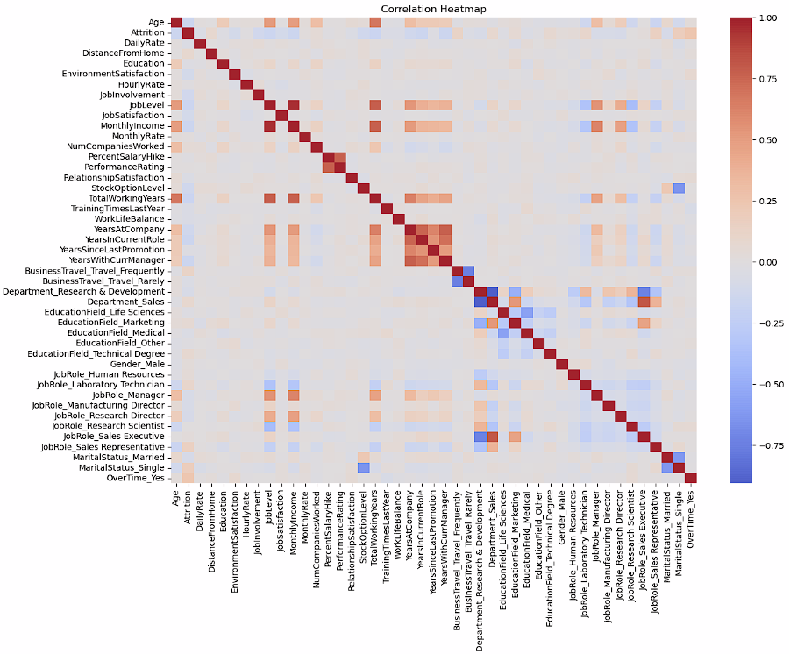
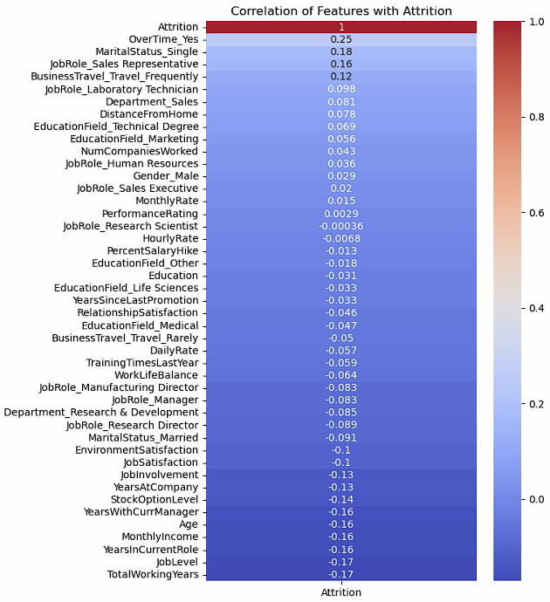
Correlation Heatmap and Correlation Coefficient Heatmap
The two heatmaps together provide a comprehensive multivariate view of how different employee attributes relate to attrition and to one another. The single-target heatmap highlights the features that is directly associated with attrition, showing that OverTime, MaritalStatus_Single, certain JobRoles, and frequent business travel have comparatively positive correlations with employees leaving the company. On the other hand, variables related to tenure, experience, job level, age, and monthly income show moderate negative correlations, indicating that more senior, experienced, and higher-paid employees are less likely to leave. Overall, the heatmaps reveals that attrition is driven by a combination of workload (OverTime), compensation (MonthlyIncome, JobLevel), career stage (Age, TotalWorkingYears), and job context (JobRole, BusinessTravel). While no single factor solely predicts turnover, the combined patterns provide strong guidance for feature selection and model interpretation.
EDA Conclusion
Exploratory Data Analysis across univariate, Bivariate and Multivariate Analysis collectively helped us figure out the factors that drive attrition. The univariate analysis highlighted variables that had meaningful variation such as the skewed distributions of MonthlyIncome, YearsAtCompany, and DistanceFromHome. These were necessary to understand the distribution of the variable along with any unusual patterns that may affect attrition. The bivariate analysis showed clear differences between employees who stayed and those who left. Employees with lower monthly income, shorter tenure, fewer total working years, longer commute distances, and lower satisfaction levels were consistently associated with higher attrition. Categorical comparisons further proved that employees who worked overtime, travelled frequently, held certain job roles, or were single showed higher attrition rates. The multivariate heatmaps confirmed these relationships by showing positive correlations between attrition and factors such as overtime, single marital status, and frequent travel, while negative correlations emerged for income, job level, age, and tenure-related variables. Together, these analyses demonstrate that attrition is not influenced by a single factor but a combination of demographic, job-related, behavioral, and satisfaction-based factors.

Experiments and Results
The machine learning process followed a structured workflow:
Data → Cleaning → Transformation → EDA → Model Training → Evaluation
Model development involved training and comparing multiple supervised learning algorithms to predict employee attrition. Our objective is to predict Employee Attrition, which is a categorical variable or binary outcome with 0 and 1, therefore, we developed classification models. We consistently evaluated all the models using metrics like Accuracy, F-1 score, Precision, Recall, and Confusion Matrix and ROC Curve for fair evaluation. After preprocessing and feature extraction, four classification models were developed to compare predictive performance:
- Baseline Model (Dummy Classifier)
The baseline model was implemented using a Dummy Classifier with the most_frequent strategy, which always predicts the majority class (“No Attrition”). This model does not learn any patterns from the data, instead, it provides a minimum benchmark that all other models must outperform.
- K-Nearest Neighbors (KNN) Classification Model
The K-Nearest Neighbors classifier was developed as a non-parametric, distance-based model that predicts attrition based on the similarity of employees. To avoid randomly selecting a value for k, hyperparameter tuning was performed by evaluating k values from 1 to 20. The optimal value was found to be k = 7, which provided the best generalization performance on the test set. The final KNN model was trained using this optimal k. Since KNN relies on distance calculations, standardized features were essential to ensure fair comparison across variables.
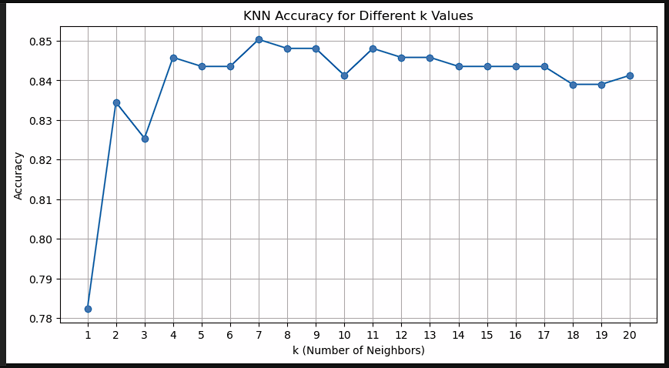
Finding the best value of k to use in our model
- Naive Bayes (GaussianNB) Classification Model
Gaussian Naive Bayes was selected as a simple, fast, and probabilistic classifier that assumes conditional independence among features. In this analysis, GaussianNB was trained on the standardized feature set and evaluated on the test data.
- Logistic Regression
Logistic Regression was developed as an interpretable linear model for the purpose of estimating the probability of employee attrition. It is best used for binary classification problems like attrition in our case. The model was trained on the standardized dataset to ensure that no features dominated.

Evaluation of Models
Model performance was evaluated using a train-test split validation method. All models were evaluated using metrics like accuracy, precision, recall, and F1‑score on the same test set to assess how well the models’ classified employees into attrition and non-attrition groups. The machine learning models that performed better than the baseline model indicated improved predictive capability.
- Baseline Model
The baseline model, which always predicts the majority class “No Attrition”, achieved an accuracy of 0.839 because this model never predicts attrition, and its precision, recall, and F1-score are all 0, meaning it does not identify employees who actually leave. The confusion matrix further visualizes that the model predicts no attrition. These are, however, insignificant as the whole purpose of Baseline Model is to serve as a benchmark for model comparison.
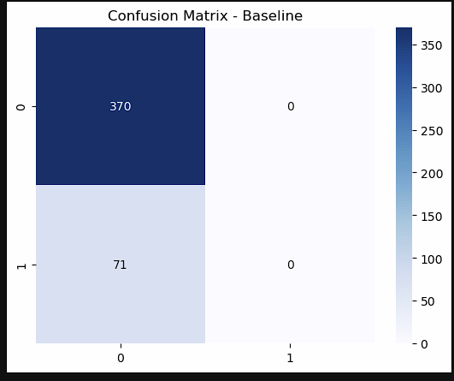
- K-Nearest Neighbors Classification Model (k=7)
KNN achieved the highest accuracy of 0.850 and strong precision=0.692, but recall was very low with 0.127, meaning it identified only a small portion of actual attrition cases. The ROC curve with an AUC of above 0.5 shows that it performs better than random guessing and has some ability to separate Attrition against No Attrition. The confusion matrix shows that the model can detect attrition cases however with high False Negative, it misses many employees who leave the company. This makes KNN good at being correct when it predicts attrition, but poor at detecting most employees who leave.
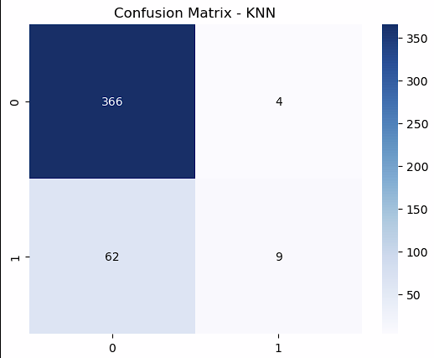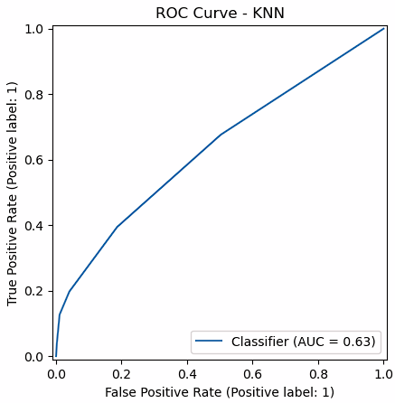
- Naive Bayes (GaussianNB) Classification Model
Naive Bayes produced the highest recall=0.718, meaning it successfully identified most employees who left. However, its accuracy of 0.635 and precision=0.266 were low, leading to many False Positives. This is justified by the confusion matrix where the False Positives are quite high. The ROC curve shows that NB Model does better than KNN, reflecting the confusion matrix of high True Negatives, low True Positives and some False Negatives. This model is useful when maximizing recall is more important than overall accuracy.
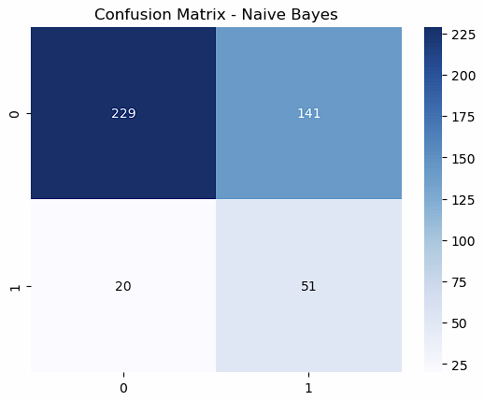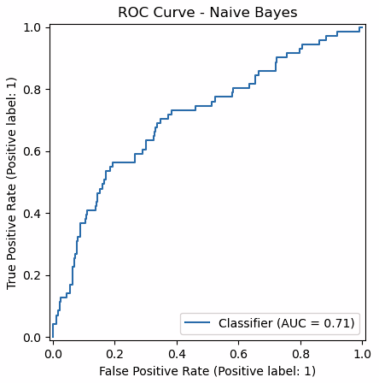
- Logistic Regression
Logistic Regression provides the most balanced performance across all metrics. With an accuracy of 0.760, precision of 0.370, and recall of 0.704, it achieves a strong compromise between identifying true attrition cases and minimizing false positives. Its F1-score of 0.485 is the highest among all models, indicating the best overall balance between precision and recall. The confusion matrix backs the argument, showing that the model correctly classifies in most cases and produces fewer false results. The ROC curve of Logistic Regression shows the best amongst all the models with the highest AUC score. This confirms that the model can distinguish between employees who stay and those who leave.
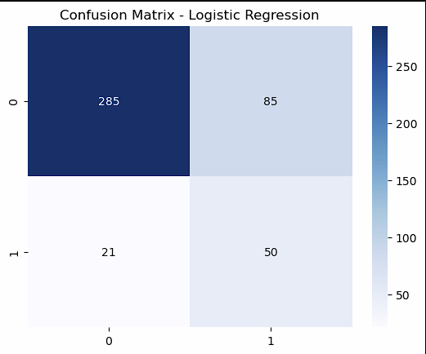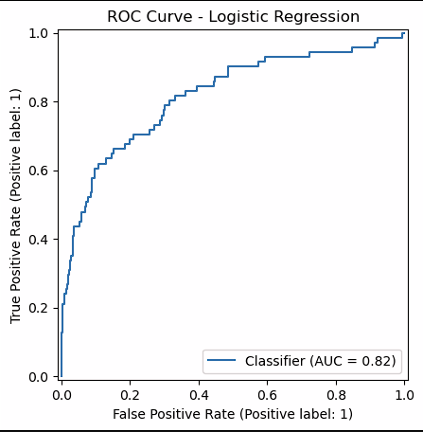
Below is a comparison table for all the models with respect to the metrics used.
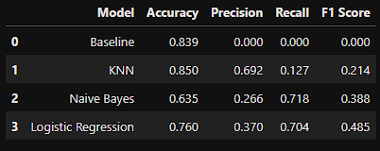
In conclusion, KNN achieved the highest accuracy but struggled with recall. Naive Bayes achieved the highest recall but at the cost of precision and accuracy. Logistic Regression provided the strongest balance across all metrics and achieved the highest F1-score, making it the best-performing model overall.

Conclusion
First, employee attrition is not random. There are patterns. In our data, people who made less money and people who worked overtime were more likely to leave. If you're not paid well and you're always working extra hours, you're probably going to look for something better.

Second, our model worked (kind of). It was better than just guessing. But it wasn't perfect. The biggest problem we ran into was that the data was unbalanced. Way more people stayed than left. So, our model got good at predicting “stay” but not as good at predicting “leave”. That's something we would fix if we did this again.

Third, machine learning can help with HR problems. Even with our simple model, we proved that you could look at employee data and find useful signals. You don't need to be a genius to do this. You just need clean data and a clear question.

The main takeaway is that, predicting who will quit is hard, but it’s possible. And for companies, even a little bit of warning is better than none. If HR knows that low-income, overtime workers are at risk, they can focus their energy on keeping those people happy.

References
Amsten (March 30, 2026). Evaluation Metrics in Machine Learning. GeeksForGeeks
https://www.geeksforgeeks.org/machine-learning/metrics-for-machine-learning-model/
Cover, T., & Hart, P. (1967). Nearest neighbor pattern classification.
IEEE Transactions on Information Theory, 13(1), 21–27.
https://doi.org/10.1109/TIT.1967.1053964
Hunter, J. D. (2007). Matplotlib: A 2D graphics environment.
Computing in Science & Engineering, 9(3), 90–95.
https://doi.org/10.1109/MCSE.2007.55
Kartik (Feb 27, 2026). Naive Bayes Classifier. GeeksForGeeks
https://www.geeksforgeeks.org/machine-learning/naive-bayes-classifiers/

Kartik (April 06, 2026). Logistic Regression in Machine Learning. GeeksForGeeks
https://www.geeksforgeeks.org/machine-learning/understanding-logistic-regression/

Kartik (April 06, 2026). K-Nearest Neighbor (KNN) Algorithm. GeeksForGeeks
https://www.geeksforgeeks.org/machine-learning/k-nearest-neighbours/

Katta (April 06, 2026). EDA - Exploratory Data Analysis in Python. GeeksForGeeks
https://www.geeksforgeeks.org/data-analysis/exploratory-data-analysis-in-python/

Lekha (March 12, 2026). One Hot Encoding in Machine Learning. GeeksForGeeks
https://www.geeksforgeeks.org/machine-learning/ml-one-hot-encoding/
McKinney, W. (2010). Data structures for statistical computing in Python.
In Proceedings of the 9th Python in Science Conference (pp. 51–56).
Moses Kurui (Nov 06, 2025). How to Create a Confusion Matrix in Python: A Comprehensive Guide. CodePointtech
https://codepointtech.com/how-to-create-a-confusion-matrix-in-python-a-comprehensive-guide/codepointtech.com

Peter S. (Sept. 15, 2025). Common Metrics for Evaluating Classification Models. MLJourney.
https://mljourney.com/common-metrics-for-evaluating-classification-models/
Saurabh B. (n.d.). HR Employee Attrition Dataset. Kaggle.
https://www.kaggle.com/datasets/saurabhbadole/hr-employee-attrition
Waskom, M. L. (2021). Seaborn: Statistical data visualization.
Journal of Open Source Software, 6(60), 3021.
https://doi.org/10.21105/joss.03021

